New Jersey Buddhist Vihara & Meditation Center
2017 Katina Celebration
Saturday, October 14
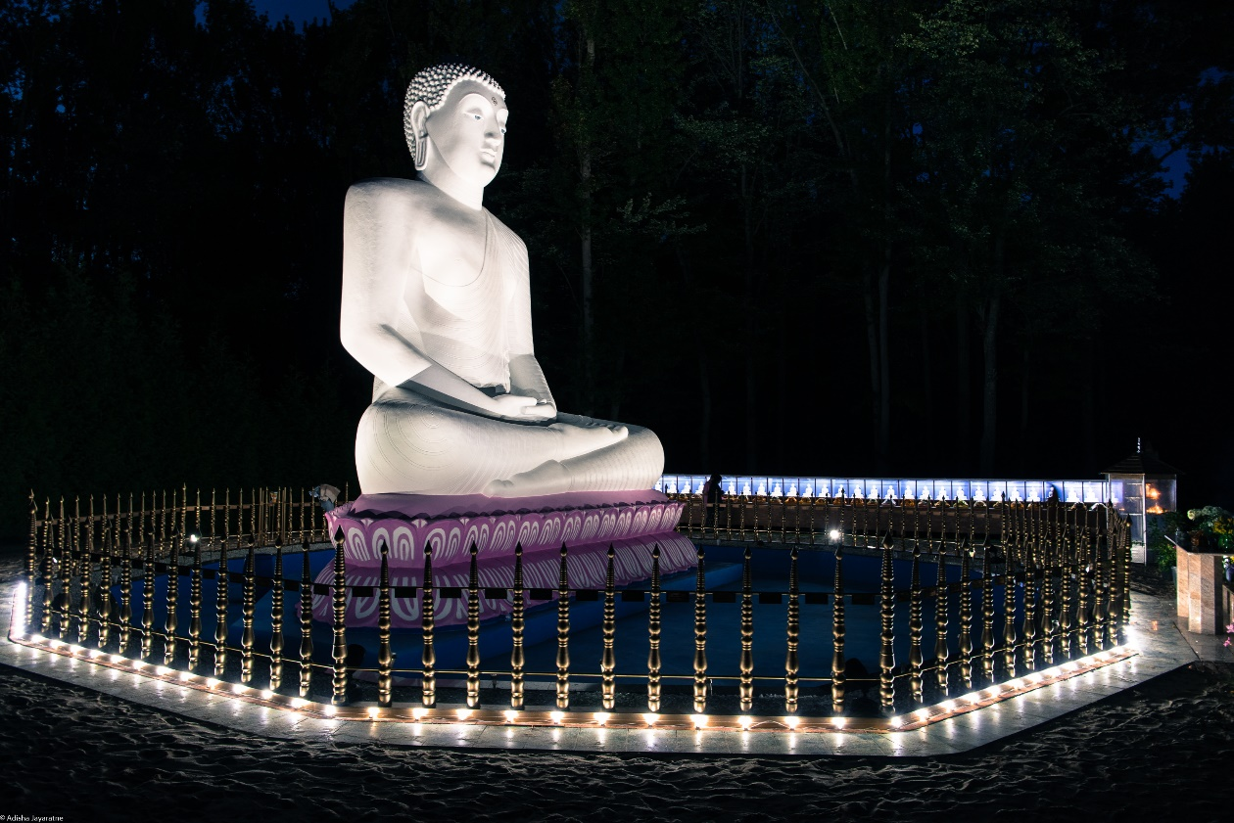
“Sabba papassa akaranum, Kusalassa upsampada
Sacitta-pariyodapnam, Etam Buddhanusasanum”

~ To keep away from all evil, cultivate good, and
purify one’s mind is the advice of all Buddhas ~

All Are Invited

Dear Devotees and Friends, thank you for your Support and Generosity.

With Metta
2017 Katina Sponsor Committee
Anura & Harini Perera ▪ Aruna & Asanthi Pieris-Gunatilaka ▪ Asanka & Margi Dharmakeerthi ▪
Chanaka & Anoji Seneviratne ▪ Chandana & Shyamalie Goonetilleke ▪ Devinda & Nilu Molligoda ▪ Gamini & Ganga Karunaratne ▪ Hemantha & Geethani Ranatunga ▪
Lasitha & Amila Abeysekera ▪ Lucky & Ranjani Athalage ▪ Nadun & Dharani Dasanayake ▪
Nalaka & Manouri Dias ▪ Pramod & Kumudika Rajapakse ▪ Saman & Sandamalie Ralapanawe ▪
Shantha & Sharma Athalage ▪ Sonal & Angie Fernando

New Jersey Buddhist Vihara & Meditation Center
4299 Route 27, Princeton NJ 08540
www.njbv.org 732-821-9436
2017 Katina Celebration - Program
Session I: Katina Vastra Perahara & Heel Dana (Morning Program)
5:30am Bring Katina Vastra (Robe) to Vihara
5:45am Katina Vastra Perahara (procession around temple ground and Samadhi Buddha Statue)
6:15am Katina Vastra offering to Maha Sanga
6:30am Heel Dana (breakfast) for Maha Sanga
7:00am Breakfast for devotees and friends
8:00am Sewing of Katina Robe begins

Session II: Dhaval Dana (Lunch Program)
8:30am-10:15am Preparation for Dana
10:15am Serving of Buddha Puja (Offering)
10:30am Buddha Puja Procession
11:15am Dana for Maha Sanga
11:30am Dana for Devotees and Friends

Session III: Katina Cheevara & Pirikara Puja (Offering Katina Robe & Pirikara)
1:15 pm Offering of Katina Cheevara
Offering of Pirikara to Maha Sanga
Katinanisansa Bana (Dhamma Talk)
Seth Pirith Chanting & Blessings
Receive Pirith Vatura and Nool (Holy Water and Thread)
3:30 pm Program Ends
Sabbe Satta Bhavantu Sukhitatta / May All Beings be Well and Happy
Katinanisansa (Merit of Katina Donations)
Dear Dhamma Friends,
All of us are jointly offering a Katina Robe along with other offerings of Pirikara, KapRuka, and Dana to the Maha Sanga, using our hard-earned money and our precious time. The effect of this offering is immensely powerful and is praised in the Buddhist texts:

▪ All Buddhas have highly praised the offering of a Katina Robe to monks as the noblest meritorious act among all offerings made on this Earth.

▪ The offering of a Katina Robe or any other item large or small accompanying such an offering, whether it is small and insignificant as a mere needle, or a reel of cotton, is held as bearing tremendous merit.

▪ The effect of offering a single Katina Robe is 16 times greater than the total effect of all other offerings.

▪ The effect of offering just one Katina Robe is 16 times greater than the total effect of offering a Maha Meru mountain high pile of two-ply robes, one-ply robes and under-robes, all made of the finest textiles.

▪ The merit of all offerings done in this world, continuously through 100 years, is not worth one sixteenth part of the effect of offering just one Katina Robe.

▪ The effect of offering just one Katina Robe is 16 times greater than the total effect of offering all five types of medicines available in this world, continuously through 100 years.

▪ A Katina Robe offering has the power to bestow upon devotees all the happiness and treasures obtainable in the human world, all divine happiness and treasures obtainable in the deva world and finally, the Supreme Bliss of Nibbana.

Idam me punnam – Asavak-khayavaham hotu
Sabba dukkha pamunchatu!
May this merit – Cause to eradicate all taints,
And may I be free from All sufferings – May I be at peace!

The 2017 Katina Sponsors Committee wish to express our sincere gratitude to
Ven. Sirirathana Nayaka Thero, the Chief Incumbent of the New Jersey Buddhist Vihara and the Vassana Season resident monks, Banthe Veneetha, and Banthe Vijitha for guiding us and all the devotees and friends of the Vihara through three months of Dana, Sila, Bhavna, Sermons, Pirith Chanting, Pahan Puja, Bodhi Puja, Buddha Gnana Puja, and many Dhamma discussions. May they have good health, long life, and ultimately the Supreme Bliss of Nibanna.

